**ĐẠI HỌC QUỐC GIA THÀNH PHỐ HỒ CHÍ MINH**

**TRƯỜNG ĐẠI HỌC CÔNG NGHỆ THÔNG TIN**

**KHOA HỆ THỐNG THÔNG TIN**

_______🙟✵🙝_______



**PROJECT REPORT**

**USING SMART CONTRACT TO SOLVE**

**REJECT TALKING DELIVERY**

Lecturer: Master Đỗ Duy Thanh

Class: *IS334.N11.HTCL*

**Group members:**

| Bùi Sĩ Khoa | 20521461 |
| --- | --- |
| Huỳnh Minh Quân | 20521789 |
| Nguyễn Hoàng Thắng | 19520949 |
|  |  |
|  |  |
|  |  |

**Ho Chi Minh City, December 30th 2022**

**LỜI CẢM ƠN**

Đầu tiên, nhóm chúng em xin gửi lời cảm ơn chân thành đến Thầy Đỗ Duy Thanh, giảng viên khoa Hệ thống Thông tin, môn Thương mại điện tử Trường Đại học Công nghệ Thông tin – Đại học Quốc gia TP.HCM đã giúp cho nhóm chúng em có những kiến thức cơ bản làm nền tảng để thực hiện đề tài này.

Thầy đã trực tiếp hướng dẫn tận tình, sửa chữa và đóng góp nhiều ý kiến quý báu giúp nhóm chúng em hoàn thành tốt báo cáo môn học của mình. Một lần nữa em chân thành cảm ơn thầy và chúc thầy dồi dào sức khoẻ.

Trong thời gian một học kỳ thực hiện đề tài, nhóm chúng em đã vận dụng những kiến thức nền tảng đã tích lũy đồng thời kết hợp với việc học hỏi và nghiên cứu những kiến thức mới từ thầy cô, bạn bè cũng như nhiều nguồn tài liệu tham khảo. Từ đó, nhóm chúng em vận dụng tối đa những gì đã thu thập được để hoàn thành một báo cáo đồ án tốt nhất. Tuy nhiên, vì kiến thức chuyên môn còn hạn chế và bản thân còn thiếu nhiều kinh nghiệm thực tiễn nên nội dung của báo cáo không tránh khỏi những thiếu xót, em rất mong nhận được sự góp ý, chỉ bảo thêm của thầy nhằm hoàn thiện những kiến thức của mỗi cá nhân để nhóm chúng em có thể dùng làm hành trang thực hiện tiếp các đề tài khác trong tương lai cũng như là trong việc học tập và làm việc sau này.

Một lần nữa nhóm xin gửi đến thầy lời cảm ơn chân thành và tốt đẹp nhất!

Thành phố Hồ Chí Minh, tháng năm 2022

Nhóm sinh viên thực hiện

**MASTER’S COMMENTS**

………………………………………………………………………………………………………………………………………………………………………………………………………………………………………………………………………………………………………………………………………………………………………………………………………………………………………………………………………………………………………………………………………………………………………………………………………………………………………………………………………………………………………………………………………………………………………………………………………………………………………………………………………………………………………………………………………………………………………………………………………………………………………………………………………………………………………………………………………………………………………………………………………………………………………………………………………………………………………………………………………………………………………………………………………………………………………………………………………………………………………………………………………………………………………………………………………………………………………………………………………………………………………………………………………………………………………………………………………………………………………………………………………………………………………………………………………………………………………………………………………………………………………………………………………………………………………………………………………………………………………………………………………………………………………………………………………………………………………………………………………………………………………………………………………………………………………………………………………………………………………………………………………………………………………………………………………………………………………………………………………………………………………………………………………………………………………………………………………………………………………………………………………………………………………………………………………………………………………………………………………………………………………………………………………………………………………………………………………………………………………………………………………………………………………………………………………………………………………………………………………………………………………………………………………………………………………………………………………………………………………………………………………………………………………………………………………………………………………………………………………………………………………………………………………………………………………………………………………………………………………………………………………………………………………………………………………………………………………………………………………………………………………………………………………………………………………………………………………………………………………………………………………………………………………………

**I.** **OVERVIEW 5**

1. Project overview 5

1.1 Motive 5

1.2 Goals 6

1.3 Accessibility and requirements 6

1.4. Group information and rules members 7

2. Blockchain introduction 8

2.1 What is blockchain? 8

2.2. Uses of blockchain 9

2.3. Blockchain programming language 11

3. Smart contract introduction 13

3.1. What is a smart contract? 13

3.2. Smart contract features 14

3.3. Smart contracts pros and cons 15

3.4. How smart contracts work 16

3.5. Smart contracts in blockchain 17

**II.** **Building an E-Commerce website 19**

1. Introduction 19

2. Features 19

3. Website overview 19

**III.** **PROJECT DEPLOYMENT 23**

1. WPSmartContracts plugin installation 23

2. Install Metamask and link to the website 24

3. Create a coin 25

1. OVERVIEW
2. Project overview

1.1 Motive

In recent years, E-commerce has been very popular. We can have an office or a shop, which oversees all business operations and the distribution of products to customers. However, we want to find ways to increase our sales quicker, reduce business operating costs and increase profit margins for our business, an E-commerce website is an effective way for us.

The Internet is a powerful platform providing a broad awareness of E-commerce websites. There are millions of people searching the internet everyday, looking for products and services. Online shopping is increasing year-on-year and is being seen as a convenient method to purchase products, where customers can also buy at any time in the day.

Additionally, E-commerce websites allow us to employ a range of marketing and sales techniques to give people that extra reason to stay on our website and buy our products.

The cost of setting up an E-commerce website is lower than an offline business one. The whole sales system for our business is automated online. Therefore, we will save on staff, wages, and other business costs, which are usually an expense such as electricity and rental costs. Our website will also help you expand your product offering faster than is normally possible within an offline business situation. We can increase revenue fast through special offers and online marketing initiatives.

1.2 Goals

Our group project is about making a website which sells small bags range from men to women styles to each variant like shoulders bags, bum bags, etc. with different color and sizes and users can view product information or information about the subject of the book bag to know the current trend. Our site also uses a form of blockchain which is smart contracts to deal with the straw buyers, scammers, etc. to provide the safest security for the website as well as the sellers and creates trust for the buyers.

1.3 Accessibility and requirements

1.3.1 Accessibility

The website is built to support small-scale business owners who can easily manage it with basic functions: manage customer members, manage products and revenue effectively.

1.3.2 Requirements

Building a website to help manage and operate activities that meet the following requirements:

* Manage customer information, administration, services, invoices.
* Manage statistics with high accuracy and efficiency.
* Website building can apply to the market.
* Fast access speed, save history of data changes on the database.
* Can run stably all versions of Windows and MacOS operating systems.
* Intuitive, user-friendly, easy-to-use interface system.
* Enhance design capabilities.
* Practice teamwork.

### 1.4. Group information and rules members

1.4.1. Members and roles

1. Bùi Sĩ Khoa – 20521461: Design Website and deploy, Create coin using WPSmart Contract, support completing report (I, II, III), slide, and report.
2. Huỳnh Minh Quân - 20521789: Help create coin using WPSmart Contract, support completing the report (I, IV), slide
3. Nguyễn Hoàng Thắng – 19520949: Support completing the report (I, V), slide

Task assignment table

| **Task** | **Bùi Sĩ Khoa** | **Nguyễn Hoàng Thắng** | **Huỳnh Minh Quân** |
| --- | --- | --- | --- |
| Brainstorming | X | X | X |
| Researching | X | X | X |
| Website creating | X |  |  |
| Create coin website | X |  | X |
| Smart contract coding |  |  | X |
| Configuration | X |  |  |
| Verification | X | X | X |
| **Percentage of tasks completion(%)** | 70 | 80 | 70 |
| **Percentage (%) of contribution for the project(total=100%)** | 50 | 15 | 35 |

1.4.2. Rules

* + - Rules of participation
* Work actively, proactively, give ideas in the discussion, keep in touch with team members.
* Equal work: men and women work with equal amounts of work.
* Problem solving rule
* Encourage everyone to participate in problem solving.
* Mainly focus on solving problems, not pushing and blaming each other.
  + - Meeting Rules
* Plan and announce the meeting at least 3 days in advance.
* Members are fully present according to the announced meeting schedule.
* Members must prepare and gather reports on content and work progress before each meeting.
* The secretary collects the minutes of the meeting.
  + - Communication Rules
* Honesty, sociability throughout the project implementation.
* Only accept comments that are constructive, encouraging, encouraging.

1.4.3. Planning

* + - Meeting frequency: 2 times/month.
    - Time: At 19:30 to 22h on the first Wednesday of each month.
    - Format: Face-to-face and online.
    - Notification via: Zalo
    - Members when receiving notification messages must respond to prove that they have received and read the notification. If a member does not respond to the meeting notice or any other announcement, the team leader will call the member.
    - Minimum notice: 24 hours.

1. Blockchain introduction

2.1 What is blockchain?

Blockchain is a technology that allows the transmission of data securely based on an extremely complex encryption system, similar to a company's ledger, where cash is closely monitored. In this case Blockchain is an accounting ledger operating in the digital realm. Blockchain possesses a very special feature that is the transmission of data does not require an intermediary to confirm the information. The Blockchain system has many independent nodes capable of validating information without requiring “signs of trust”. Information in the Blockchain cannot be changed and can only be added when there is a consensus of all nodes in the system. This is a highly secure system against the possibility of data theft. Even if part of the Blockchain system collapses, those computers and other nodes will continue to protect the information and keep the network going.

Blockchain technology can be said to be a combination of the following 3 technologies:

* Cryptography: Using public keys and hash functions to ensure transparency, integrity, and privacy.
* Peer-to-peer network: Each node in the network is considered as a client and also a server to store a copy of the application.
* Game theory: All nodes participating in the system must obey the rules of the consensus game (PoW, PoS…) and are motivated by economic motivation.

From a business perspective, it can be called an accounting ledger, or a database containing assets, or a data structure, which is used to record the history of assets between members in the network. in the same level.

From a technical perspective it is an immutable method to store the history of asset transactions.

From a social perspective it is a phenomenon, which is used to establish trust by consensus rules among members in a hierarchy.

The idea of ​​​​the birth of Blockchain

Derived from the problem of Byzantine Generals in computer science and dealing with reliable transmission in a hierarchical system.

The content of the problem describes: An army goes to capture the citadel and the generals are located in different positions. In which there are N loyal generals who want to capture the citadel and M traitors who want to withdraw their troops, a traitor general informs one group to attack and informs another group to withdraw troops. So how can the generals be consistent with information and capture the city together? Just one mistake in the transmission of information can cause an entire army to be annihilated.

2.2. Uses of blockchain

Increase the working efficiency of the system

This is the first and most important feature of this software. The best thing about Blockchain is that it can increase the operating capacity of the entire system. Thanks to the fact that there will be many computers working at the same time in the same network, it helps to work more efficiently – more optimally than just concentrating control on a specific computer.

Better security features

Blockchain technology will have better security because there won't be any loopholes that can be exploited to bring down the system – even the most potentially risky financial systems. . For example, the Bitcoin software has never been hacked, because the Bitcoin Blockchain system is secured by many different computers called nodes, and they guarantee the confirmation of those who need it. transaction in the system

1. Stability

Building a stable ledger is the core goal of Blockchain. Any centralized platform can be easily penetrated by hackers and requires trust from a third party. However, a Blockchain system like Bitcoin always keeps its ledger data in a stable forwarded state. We will always need to reach a consensus among miners (Bitcoin users), exchanges (transactions) and nodes operator in Bitcoin to be able to change the data of the Blockchain.

1. Faster processing

The traditional banking system will take many days to process the data. This leads to the reason why banks always need to update their systems regularly. However, Blockchain can completely handle this problem because they process data at a very fast speed. This advantage has helped many banks save a lot of time, money and bring convenience to their customers.

1. Decentralized Platform

Decentralized technology gives you the ability to store assets (such as contracts, documents, etc.) into the system via the Internet. The owner will have direct control of the system and transfer his assets to any other person through a private key (virtual key).

Blockchain technology has proven itself in the process of decentralizing the web and has the power to bring about enormous change in all industries.

1. Correctiveness

Through the technology of Blockchain, we will be able to solve the problems related to fraud. In particular, countries - where user confidence in technology features is still low - will be the "land of hope" for the development of Blockchain software.

Blockchain technology is used for a variety of purposes from providing financial services to administering voting systems. Here are the most popular uses of blockchain:

Cryptocurrencies: The most common use of blockchain today is cryptocurrencies like Bitcoin or Ethereum. When people buy, exchange, or spend cryptocurrency, the transactions are recorded on a blockchain. The more people use cryptocurrency, the more popular blockchain can become.

Banking: In addition to cryptocurrencies, blockchain is being used to process transactions in fiat currencies like USD and EUR. This technology makes bank deposits faster and transactions verified faster outside of normal business hours.

Asset transfer: Blockchain can also be used to record and transfer ownership of various assets. This technology is currently very popular with digital assets such as NFT - a representation of ownership of digital art and video.

Smart Contracts: Another application of blockchain is self-executing contracts often referred to as “smart contracts”. These digital contracts are issued automatically once the conditions are met.

Supply Chain Monitoring: Supply chains include a large amount of information, especially as goods travel from one part of the world. Storing this information on the blockchain will make it easier to go back and monitor the supply chain.

Voting: Experts are looking to apply blockchain to prevent fraud in voting. In theory, blockchain voting would allow anyone to submit votes that cannot be tampered with.

2.3. Blockchain programming language

2.3.1. What is Solidity?

Solidity is a programming language built under the inheritance of appropriate features of other programming languages, especially those related to contracts.

Data types used in Solidity

Similar to other programming languages, Solidity uses common data types such as: integer type - Integer, data type 0.1 or corresponding to true, false - boolean, string type - string literals,... In addition, there are many other data types compatible with Solidity such as arrays, operators, enums, etc. In general, Solidity language allows users to use almost all data types. popular today.

There are now so many usable programming languages, so why are there still so many new ones being born? The development of these new programming languages ​​is always aimed at the common goal of professionalism to make it easier for programmers and solve problems and problems in the most perfect way. And of course, Solidity was born for that very reason.

As a programming language built to solve the problems of contracts and the Ethereum ecosystem, Solidity provides tools that often revolve around dealing with these problems.

Solgraph

Solidity REPL

Evmdis

EVM lab: this is the most useful package of tools that Solidity provides to users. This tool pack includes a set of statements along with rich and useful syntax tutorials for programmers.

2.3.2. Pros and cons of Solidity

1. Solidity advantages:

• Enables the construction of reliable, secure and transparent smart contracts; thereby helping to improve operational efficiency, reduce administrative costs as well as dependence on third parties.

• Using a large amount of programming knowledge from other programming languages ​​in manipulating classes, strings, math, functions, etc. such as C++, JavaScript, Python... so developers can easily learn Solidity quickly.

• Programming language commonly used today; provide a variety of open source documentation in different application formats and scenarios; so programmers can easily create complex applications from other people's products.

1. Cons of Solidity:

• Once the contract is done, the application will not be able to upgrade, additional features cannot be added

• Ethereum runs on Blockchain platform, cannot update and collect information quickly from the system except for transaction activities.

• Facing immaturity when compared with Java and C++. Developers will have very little documentation and reference libraries.

2.3.3. How Solidity works

Solidity is used to build and design Smart Contracts.

Solidity codes will be compiled to Ethereum Bytecodes and executed by EVM into applications running on Ethereum.

EVM is an acronym for Ethereum Virtual Machine. It provides a runtime environment for Ethereum smart contracts.

Smart contracts allow you to conduct reliable transactions without the involvement of a third party. These transactions are easily traceable and irreversible.

The programming languages ​​commonly used to create and write smart contracts are Serpent, Solidity, Mutan, and LLL.

Some blockchain platforms that support Solidity:

• Ethereum

• Binance Smart Chain

• Ethereum Classic

• Tron

• Hedera Hashgraph

• Avalanche

Public and Private functions of Solidity

Public functions are similar to APIs that are accessible to anyone in the world. Anyone can call these APIs.

For example, a public function can be implemented to allow all users of a platform to check their account balances. One of the most popular ways to mine smart contracts is through public functions.

Private functions are only called from within contracts. They contain instructions that can only be executed after being called by other functions in a chain.

Standards and code logic in Solidity:

Standards for how Solidity Smart Contracts are used to build applications on Ethereum are gradually being defined. These standards are known as ERC (Ethereum Request for Comments) standards.

1. Smart contract introduction

3.1. What is a smart contract?

A Smart Contract is not a written contract on paper of the traditional kind, nor is it simply an online contract. It is described as “smart” because it can do more than both of these paradigms, in the same way that a “smartphone” can do more than just making calls. It takes the form of computer code on a Distributed Ledger Technology

DLT in a manner comparable to a formula in the cell of an Excel spreadsheet—it adjusts itself or transfers payment or other assets, monitors stock levels, or effects other actions automatically because that is what it is programmed to do. Contracts have been concluded online for many years. Indeed, a large proportion of all shares in the US are traded through automated systems. With a Smart Contract the key enhancement is self-execution through the combination of its ability to react to “online” data triggers, and the access of the Smart Contract to the value itself. It is the combination of Smart Contracts and DLT that leads people refer to Blockchain as “the Internet of Value” or “the World-Wide Ledger.” It is also this combination which makes “Smart Contracts” the most transformative Blockchain application at time of writing, since they allow a new standard of trading - disintermediated, safe, efficient, and without a central point of potential failure.

Contracts have been concluded online for many years. Indeed, a large proportion of all shares in the US are traded through automated systems. With a Smart Contract the key enhancement is self-execution through the combination of its ability to react to “online” data triggers, and the access of the Smart Contract to the value itself.

The Smart Contract goes further than that customary online paradigm. Not only does it define the next step, it executes it by re-ordering the textbook from the next supplier, and if necessary transferring value captured on the DLT from seller to buyer to represent a time penalty against the book seller. Access to this value is granted to the Smart Contract because it sits within a DLT which captures that value. Incidentally, it is not that the Smart Contract needs to be embedded on the same DLT as the value to be transferred, it just needs a command function over it.

Smart contract creators:

The idea of ​​a smart contract was originally introduced by Nick Szabo, a famous American cryptographer. In 1996, his paper on smart contracts was published in the journal Extropy, where he predicted the benefits and features of blockchain contract applications. He then developed the concept in several papers in the following years.

Ian Grigg and Gary Howland are other contributors to the idea of ​​smart contracts. They published their work on the Ricardo Contract as part of the Ricardo payment system in 1996.

The implementation of smart contracts became possible after the birth of Bitcoin and the blockchain, creating the right conditions. This innovation was finally broadcast a few years later on the Ethereum blockchain. Today, many alternative platforms allow users to take advantage of this functionality, although Ethereum remains the pioneer.

### 3.2. Smart contract features

Smart contracts have several distinctive features that set them apart from other forms of financial transactions:

• Autonomy: Users have full control over their agreement. The smart contract itself is a guarantee that excludes the possibility of interference by any other third party (broker, lawyer, notary, etc.).

• Security: The essential purpose is to ensure the security of transactions. Information entered into the blockchain cannot be deleted or modified. Even if one of the parties violates the terms of the agreement, the agreement remains intact.

• Speed: Document processing takes a long time if done manually and this slows down the completion of the task. Smart contracts minimize individual involvement and increase overall efficiency.

• Trust: Transaction participants do not need to trust each other or third parties. The decentralized network provides an environment that ensures task completion without problems or delays.

• Cost-effective: It can eliminate excessive transaction costs. And possibly by removing intermediaries from the process and facilitating the deal.

• Accuracy: The process is automated, so the possibility of human error is greatly reduced.

3.3. Smart contracts pros and cons

1. Advantages

The advantages of smart contracts are obvious and form the basis for the growing popularity of smart contracts. It's autonomy, security, high performance speed, and the ability to cut costs associated with intermediaries. People choose them because they promise affordable yet accurate and efficient commercial transactions.

1. Disadvantages

Error on smart contracts

Smart contracts allow to exclude problems that can occur due to human factors in the operation process, that's true. But at the same time, there can be mistakes and vulnerabilities in the smart contract's code itself. These mistakes can lead to huge losses. There are too many examples of when the platform was hacked and funds were stolen due to some code error. An example is the famous DAO hack.

Ambiguous terms

The legitimacy of smart contracts is another point of discussion. It is not clear how governments and regulatory agencies should handle and regulate them when they are outside the state's legal system. It is a controversial question if they can even qualify to be contracted by government entities. Being outside the legal system also means that criminals can use this technology for illegal activities. Ultimately, that's because smart contracts aren't always black and white. As a result, the terms and conditions are quite vague.

Irreversible nature

Not being able to change something in a smart contract can also be a disadvantage. Fixing errors and changing contract terms will be a difficult problem.

Invasion of privacy

Transparency is a great thing, but not always. Sometimes users need some privacy. Some platforms try to provide “private smart contracts” to their users, but this practice is unusual. Besides, the introduction of new technology can also involve costs. Only an experienced developer can create a reliable smart contract.

### 3.4. How smart contracts work

Smart contract refers to a computer algorithm designed to form, control, and provide information about content owners. It is actually a program that runs on the Ethereum blockchain to independently facilitate, verify, or execute trusted transactions. To know how it works, we must first understand what a smart contract consists of.

• Signature. Two or more parties must agree to proceed with the proposed terms and conditions.

• Clearly define the subject of the contract. The subject must be in the context of the smart contract environment.

• Be specific with the terms. Terms need to be precise and detailed. For example, Ethereum's smart contract is based on the Solidity and Serpent programming languages, so the agreement must follow specific mathematical terms compatible with the exact language.

As mentioned above, smart contracts represent computer protocols or simply pieces of code that are a fundamental technological element. They serve to specify all the conditions of agreements concluded between parties dealing with the blockchain. As soon as these conditions are fulfilled, the smart contract will automatically execute the transaction.

A blockchain-based system that allows participants to reduce middlemen and redundancies as it relies on a public order book where any interested party can verify all transactions . The central requirement here is to describe all agreement conditions through mathematical rules with the right programming language.

The blockchain represents a distributed network of nodes, each of which stores information about all transactions. To undo a transaction or double spend, one would have to gain control of more than 50% of all these nodes.

Suppose a person wants to start a smart contract, they will need to download special software and generate a public key that is published in the system. Then an initialization message will be sent and the nodes will receive it. When the event set by the smart contract is completed, the code will execute.

For example, a vending machine offers a buyer an ordered item if specific requirements are met (a certain amount is paid). Smart contracts work the same way.

* In addition to remittances, there are several other use cases:

• Digital identity: eliminate counterfeiting and provide personal identity to digital assets.

• Financial security: perfect for debt management, automatic payments or stock splits.

• Trading Operations: Smart contracts provide a great way to automate trading operations. In addition, cross-border payments and international transactions become more manageable with their help.

• Clinical Trials: It provides visibility across organizations, facilitates and automates data sharing, and enhances security.

• Governance: Smart contracts can improve the transparency and efficiency of voting.

Smart contract use cases are variable and cover many opportunities. In terms of potential, they can become a powerful tool in many areas of human activity.

3.5. Smart contracts in blockchain

Smart contract refers to a computer algorithm designed to form, control, and provide information about content owners. It is actually a program that runs on the Ethereum blockchain to independently facilitate, verify, or execute trusted transactions. To know how it works, we must first understand what a smart contract consists of.

• Signature. Two or more parties must agree to proceed with the proposed terms and conditions.

• Clearly define the subject of the contract. The subject must be in the context of the smart contract environment.

• Be specific with the terms. Terms need to be precise and detailed. For example, Ethereum's smart contract is based on the Solidity and Serpent programming languages, so the agreement must follow specific mathematical terms compatible with the exact language.

As mentioned above, smart contracts represent computer protocols or simply pieces of code that are a fundamental technological element. They serve to specify all the conditions of agreements concluded between parties dealing with the blockchain. As soon as these conditions are fulfilled, the smart contract will automatically execute the transaction.

A blockchain-based system that allows participants to reduce middlemen and redundancies as it relies on a public order book where any interested party can verify all transactions . The central requirement here is to describe all agreement conditions through mathematical rules with the right programming language.

The blockchain represents a distributed network of nodes, each of which stores information about all transactions. To undo a transaction or double spend, one would have to gain control of more than 50% of all these nodes.

Suppose a person wants to start a smart contract, they will need to download special software and generate a public key that is published in the system. Then an initialization message will be sent and the nodes will receive it. When the event set by the smart contract is completed, the code will execute.

For example, a vending machine offers a buyer an ordered item if specific requirements are met (a certain amount is paid). Smart contracts work the same way.

* In addition to remittances, there are several other use cases:

• Digital identity: eliminate counterfeiting and provide personal identity to digital assets.

• Financial security: perfect for debt management, automatic payments or stock splits.

• Trading Operations: Smart contracts provide a great way to automate trading operations. In addition, cross-border payments and international transactions become more manageable with their help.

• Clinical Trials: It provides visibility across organizations, facilitates and automates data sharing, and enhances security.

• Governance: Smart contracts can improve the transparency and efficiency of voting.

Smart contract use cases are variable and cover many opportunities. In terms of potential, they can become a powerful tool in many areas of human activity.

1. Building an E-Commerce website
   1. Introduction

* Website: Beaubag
* Topic: Trading all kinds of fashion items about bags such as briefcases, suitcases, ...
* Easy to manage customer information, administration, services, invoices.
* Manage statistics with high accuracy and efficiency.
* Website building can apply to the market.
* Fast access speed, save history of data changes on the database.
* Can run stably all versions of Windows and MacOS operating systems.
* Intuitive, user-friendly, easy-to-use interface system.
* Enhance design capabilities.
  1. Features

1. Purchase feature: It is necessary to create a shopping cart and purchase feature in a simple way so that customers can easily choose and purchase with just a few clicks. If this feature is too complicated, it will be annoying and unpopular, causing a large loss of potential customers.
2. Information viewing feature: Need to create a blog so that customers can see daily information about bags as well as fashion styles with modern trends.
   1. Website overview

Here we have pages: home page, product page, single product page, blogs page, policy page, about us, admin page, shopping cart page and admin page

This is the interface of homepage



This is the interface of product page

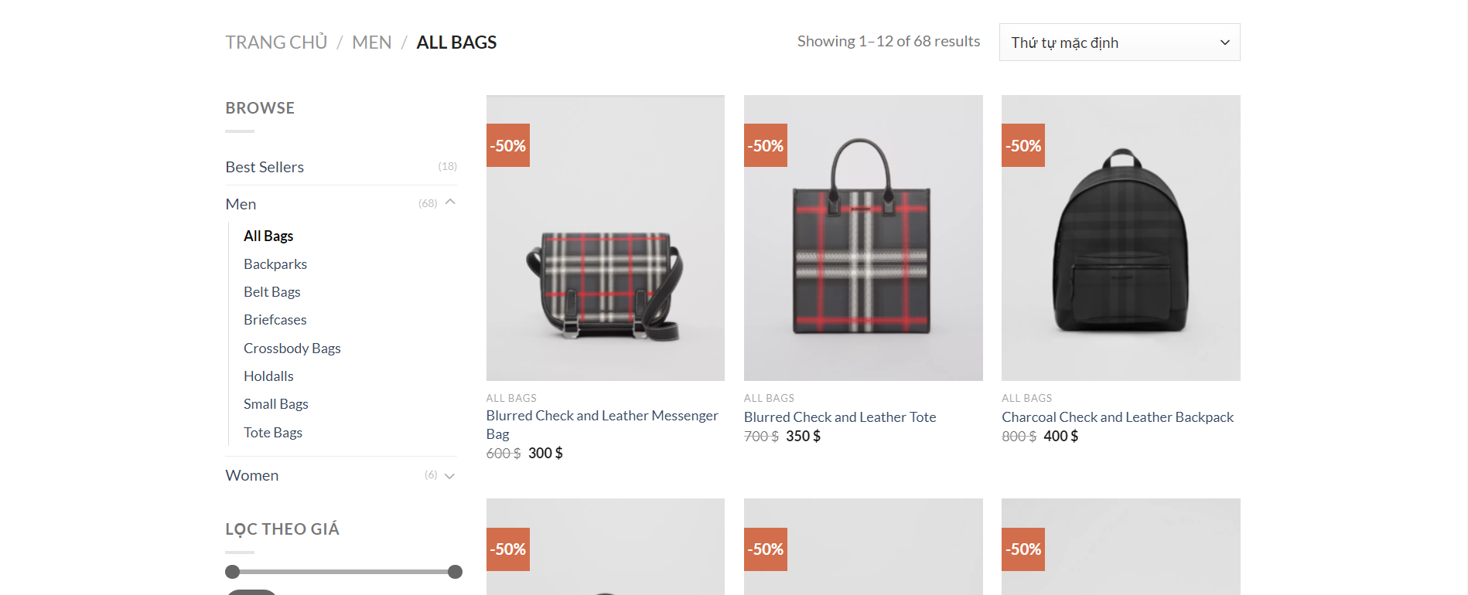

On the product page, we divide it into 3 different categories on the navigation: best seller category, signature bags, men and women

On the product page, there are subcategories such as: All bags, Crossbody bags, top handle bags, tote bags, small bags, briefcases...

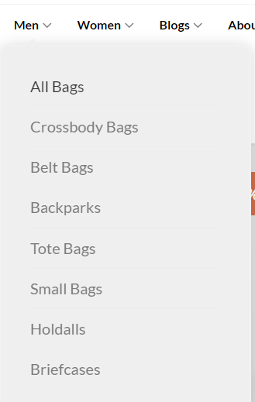

On the about us page, we talk about our history of formation and development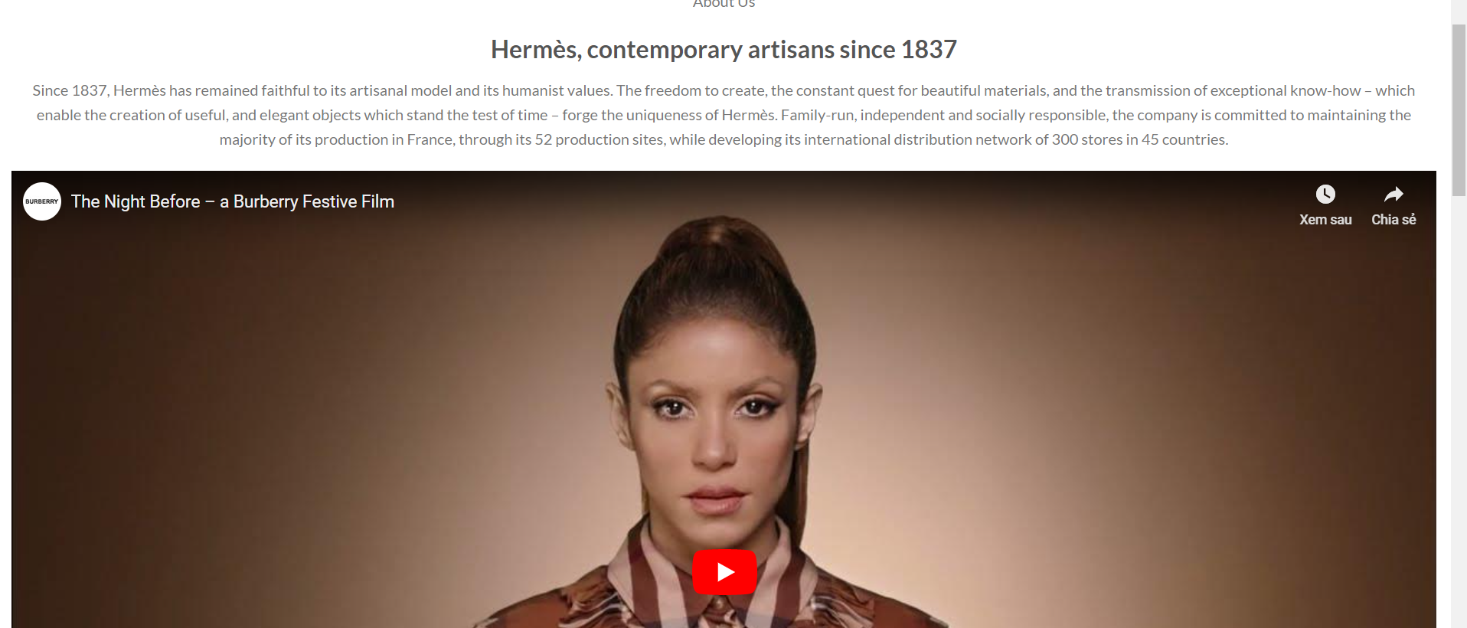

This is the interface of order page

This is the interface of shopping cart. Here, customer can add the number of product and delete product if they change their mind about it

This is the interface of payment, customer fill the form and choose purchase method, and payment

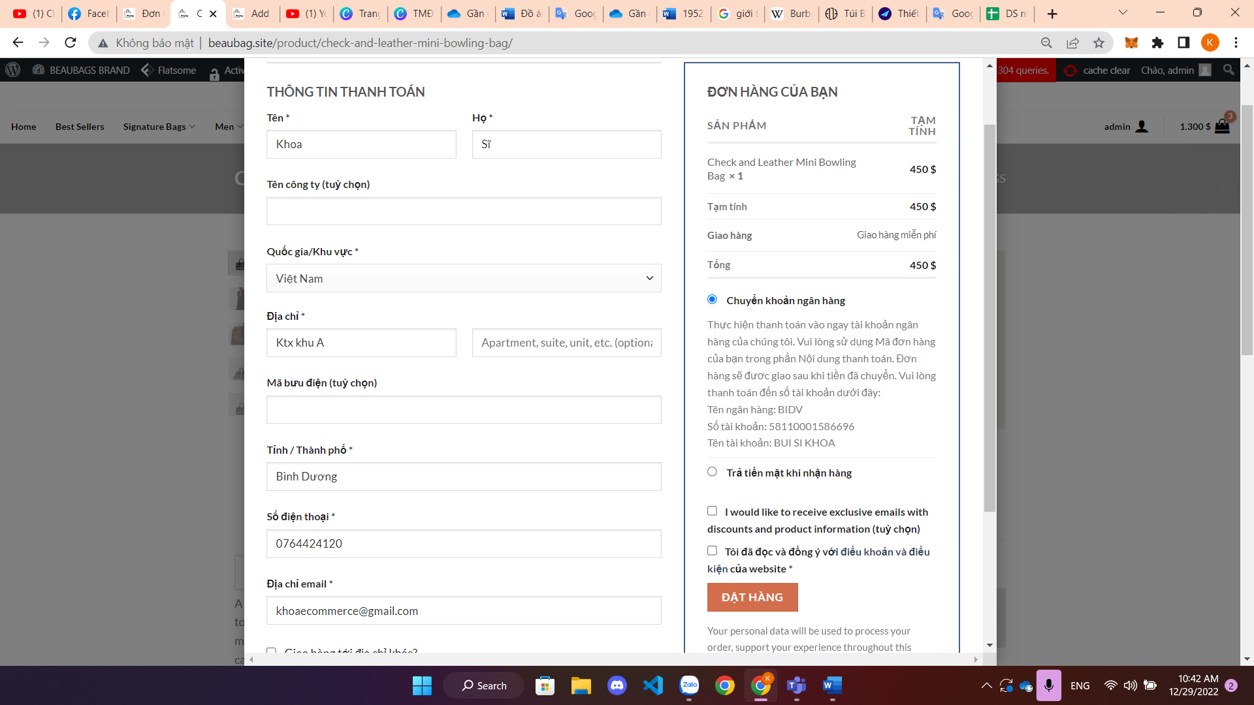

This is the interface of account, here user can edit and update your name, password…

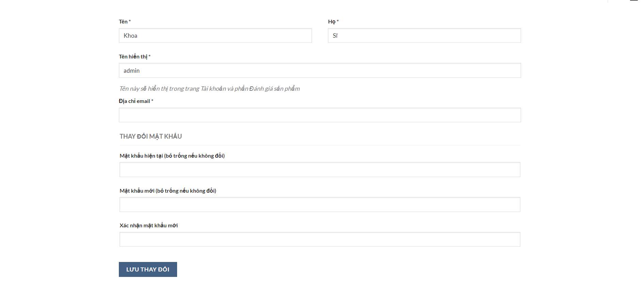

This is the interface of footer, user can click on tag to search for related information, or contact the store and know information for the services of us

This is the interface of warranty policy page

This is the interface of VIP member page

This is the interface of return policy page

1. PROJECT DEPLOYMENT
   1. WPSmartContracts plugin installation

First, you just need to install the WP Smart Contracts plugin. You can download it from their site, but it’s easiest to simply search for it in your Add New Plugins dashboard:

Install and Activate as you would any other plugin.

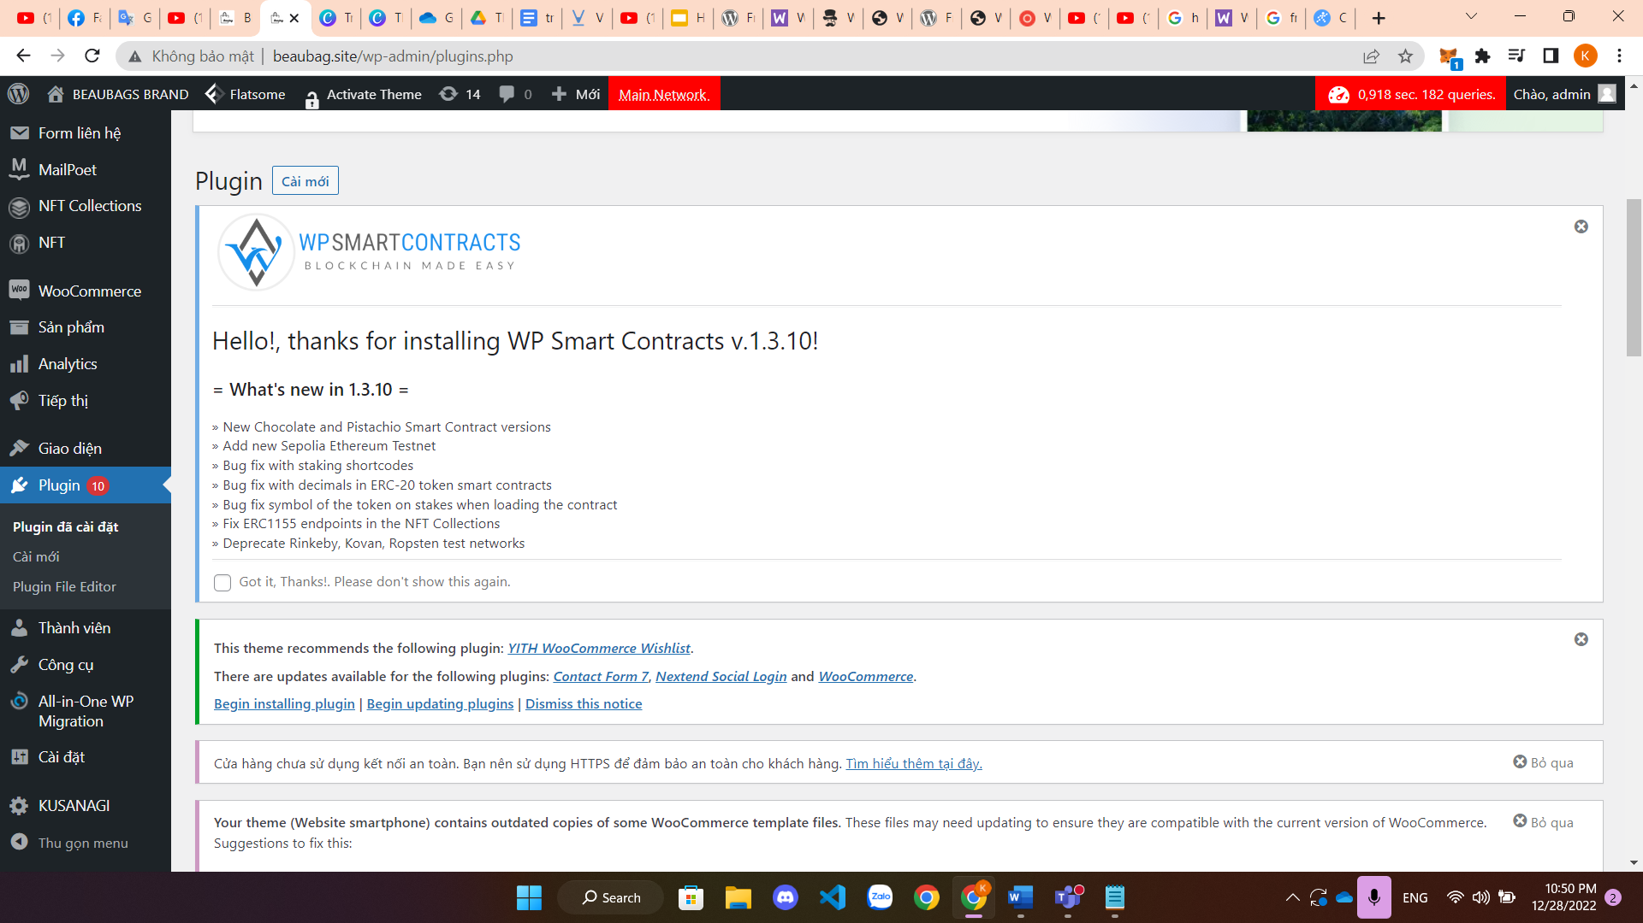

Set up an Infura account: As soon as you activate WP Smart Contracts, you’ll get an alert telling you that you need an Infura Project ID.

Infura provides the APIs you need to get access to the Ethereum network. Simply click the Infura Project ID link in the alert window and you’ll be transferred to the Infura website to set up your free account. Create a project and look at the settings: You need to copy the Project ID – not the Project Secret – and head back to WordPress.

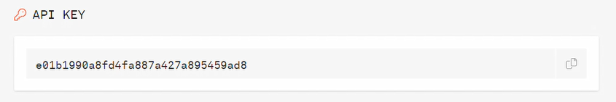

In the dashboard, navigate to Settings>WP Smart Contracts. Scroll to the bottom of the settings page and you’ll see the Infura box where you can paste your Project ID. That’s it!

* 1. Install Metamask and link to the website

Before you can start creating and deploying smart contracts, you need to install and connect to a network using MetaMask. Metamask is a wallet and dApp browser extension that allows you to secure your funds and interact with EVM Smart Contracts online.

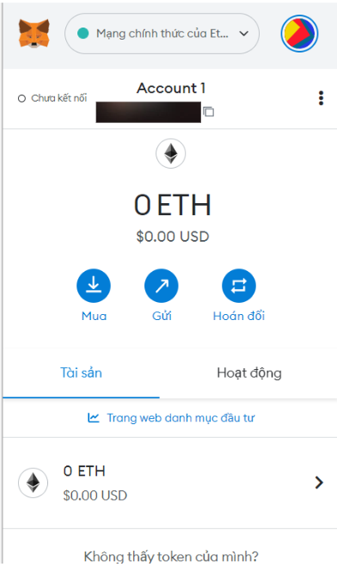

WP Smart Contracts provides a detailed tutorial to get you set up with MetaMask:

Follow their directions to connect to a test network, where you can get a couple of free tokens to start playing with. You’ll need to have some tokens to deploy smart contracts on your site, and doing it in a test environment before launching to the mainnet is highly recommended.

Any time you want to see your MetaMask wallet, just click the fox head in your browser and you can see your stats or change networks.

You’ll also see your current network connection reflected at the top of your WordPress admin dashboard.

* 1. Create a coin

Create a Smart Contract

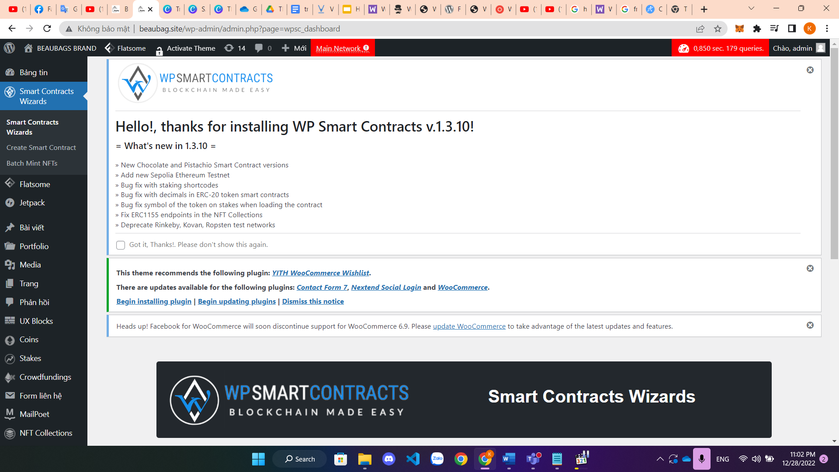

The easiest way to get started creating smart contracts is by using the WP Smart Contracts wizard. Just click on the link at the top of your admin menu bar, and you’ll be presented with choices:

For example, let’s create some cryptocurrency. Once you click the Create a Coin button, you’ll be taken to the coin wizard menu. From there, you can choose which flavor of token you want to create:

* Vanilla: Gas Saving Token
* Pistachio: Improved Security Token
* Chocolate: Advanced Token

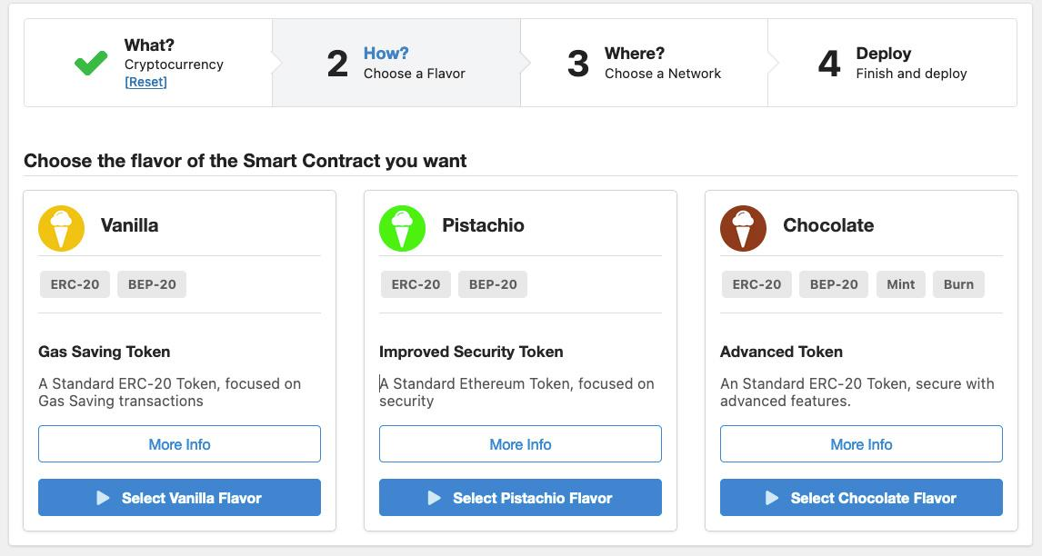

From there, you need to decide the network where you want to make your token available. You can filter by Network Type or Blockchain Type. Again, I would recommend starting with a test network such as Ethereum Ropstein. It’s free to test and your token isn’t deployed to the mainnet while you’re just figuring out how things work.

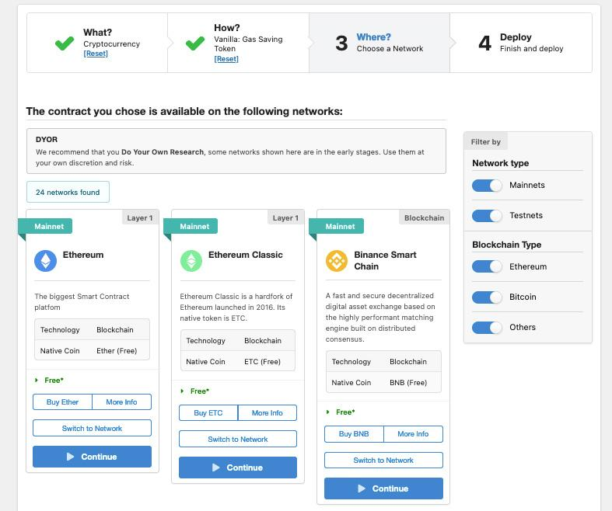

The next screen is essentially a custom post type titled “Add New Coin.” You can create a name (title) for your coin, add a description, and you once again have the option of choosing the coin type, or flavor.

Under the Definition menu, you can name the coin (if you hadn’t already), create a symbol, designate how many decimals it should be, and decide on an initial supply.

Scroll down to the New Smart Contract menu, where you can finally deploy your coin.

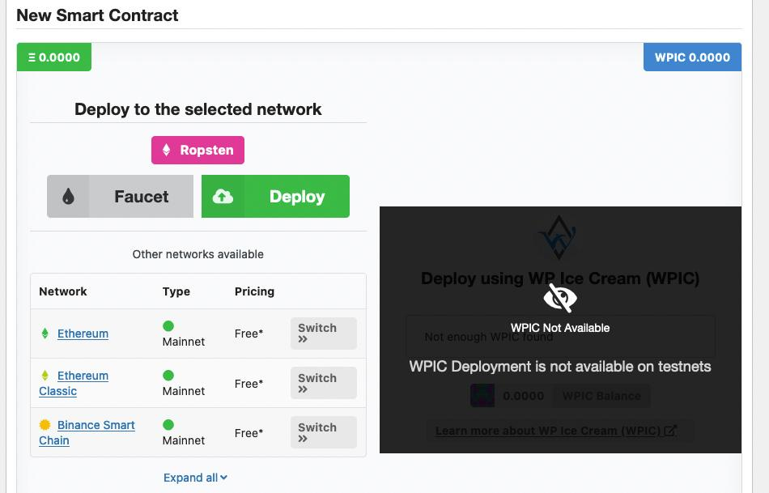

You’ll be presented with a pop up where you need to agree to the Terms of Service and that you’re of legal age. Once you click on “Yes, please proceed,” you’ll need to confirm in the Meta Mask window that pops up.

After a minute or two, your coin will be deployed and you can “View Post” to see it on your site:

That’s it! You can follow the wizard to create any smart contract you like, or start from scratch using the Add New links in your WordPress dashboard menu.

After you’ve tried creating a few test smart contracts, let’s look at customization!

1. CONCLUSION

* In short our project creates a website from WordPress that aims on selling bags with a simple but effective interface and creating a smart contract to deal with straw buyers and bots by using plugins which helped us minimizing the time dealing with them compared to the normal contracts. Our group has also dived deep into the definition of Blockchain and learned how smart contracts work and its applications on our website.
* The project our group created may not be a complete success since there are some faults in smart contracts configuration in the website and the report we made look too simple but we are ready to hear from master Thanh to help us improve on what we can do to make the project better

1. REFERENCES
2. Our Website: [Beaubag.site](http://beaubag.site)
3. Book: Blockchain and Smart Contracts: Design Thinking and Programming for FinTech (Swee Won Lo (Author), Yu Wang (Author), David Kuo Chuen Lee (Author))
4. Book: Legal Tech, Smart Contracts and Blockchain (Marcelo Corrales Mark Fenwick Helena Haapio)
5. SmartContract:<https://wpmayor.com/wp-smart-contracts-blockchain-technology-for-wordpress/>
6. Metamask:<https://wpsmartcontracts.com/docs/doc-wallets-metamask.php>
7. <https://www.youtube.com/watch?v=jz1-CyTCClc&ab_channel=ThisIsBelowZero>